Title or Task: | Rollovers in Dreamweaver  

Description:

Files Required
Suitable for Classes: | AIT • Multimedia • Cert II IT • Cert II Bus
Area: | Technology & Enterprise
Teacher: | Mr Peter Faulks
Timeline | 10 Minutes

Date Due:

Task Brief:

Outcomes:

Items highlighted in yellow are tasks for you to complete
Items in Purple are help tips

HOME
Topic:

Timeline:
HOME

Task Brief: Creating Rollovers for your personal web page

Presented by: Peter J Faulks

- Open drawing program
- Make a button by dragging a rectangle 10cm by 5 cm
- Fill it with a colour background that you like
- Select a colour for the font and type HOME centered on the button
- Save this (Right Mouse Click) as home1.jpg
- Return to Drawing program and change the look of HOME by altering the font colour or background.
- Save this to you site folder as home2.jpg
- Repeat this process making five sets of buttons (ten different graphics).
- Set 1 = HOME button home1.jpg home2.jpg
- Set 2 = Page1 button Page1a.jpg Page1b.jpg
- Set 3 = Page2 button Page2a.jpg Page2b.jpg
- Set 4 = Page3 button Page3a.jpg Page3b.jpg
- Set 5 = Contact button Contact1.jpg Contact2.jpg
- Open Dreamweaver and follow instructions below

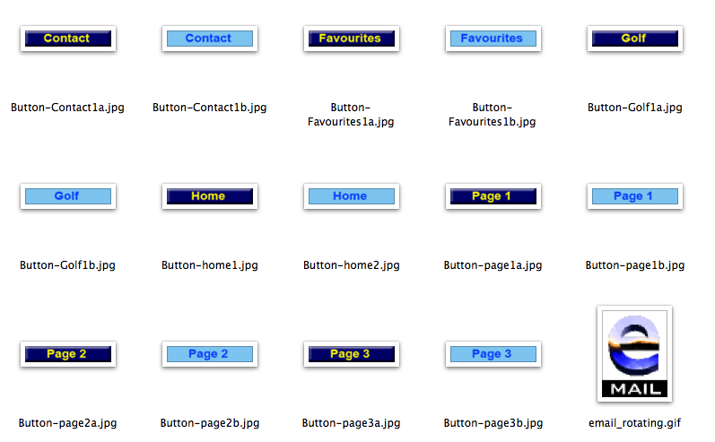
- Go to Dreamweaver and make a table 1 row by five columns leave Border at 1 to show a border (Border 0 = no border - Border 5 = thick border)
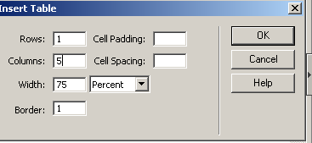
- Click in the first cell and from the menus bar (top of screen) select Insert

- Click on Insert interactive images – Rollover Image

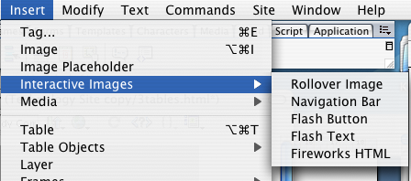

- Title this home

- Browse to the first image (home1.jpg)

- Then click Browse… to add (home2.jpg)

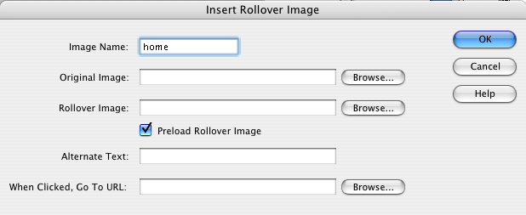
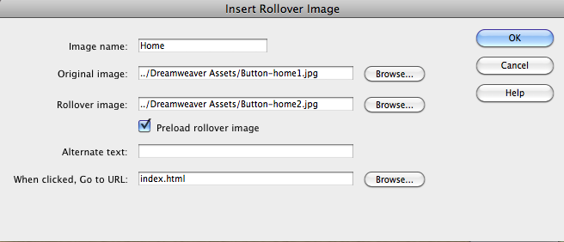

Click O.K. and your first rollover button has been inserted.

- Click in the next cell and insert page1

- Repeat for all pages and the contact rollover.

- Save your file and test your rollovers (Preview in Browser) in the iexplore browser

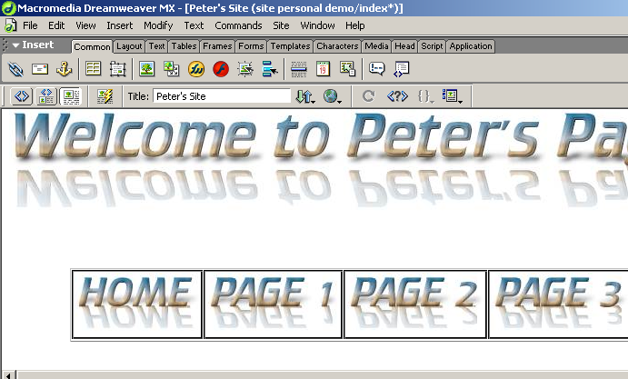

Once you have created your rollover buttons click back in Dreamweaver and insert the links
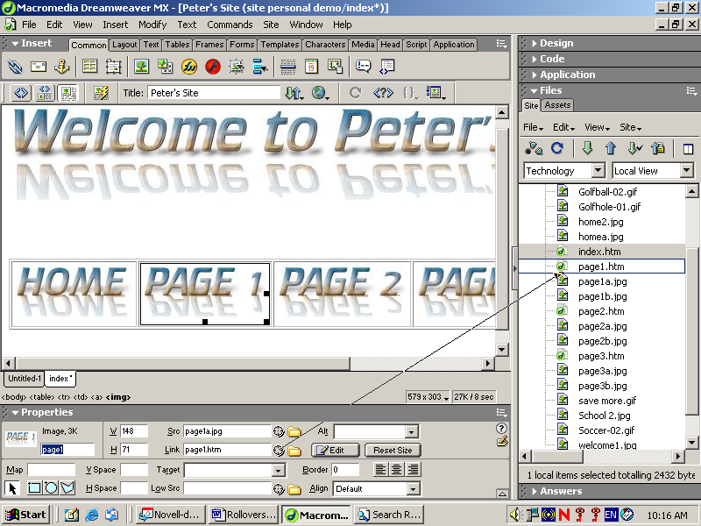

Use the point to file for each link.

For the contact button your link will be: (your name)

mailto:yourname@server.com.au

Check that all the links work and save you work.

Select all the table including the buttons and copy them to each page

ADVANCED – Creating Snippets

Add a content code snppet
Next you’ll add the table to the snippets library
Click on Snippets library in the Code window
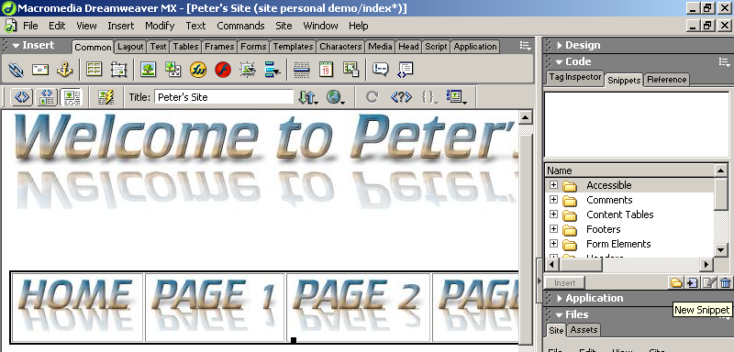

- Select the table with your rollover in place.
- In the Snippets panel, click the plus (+) button in front of the Table, then click the plus (+) button in the Snippet window
- Title the snippet Toolbar1
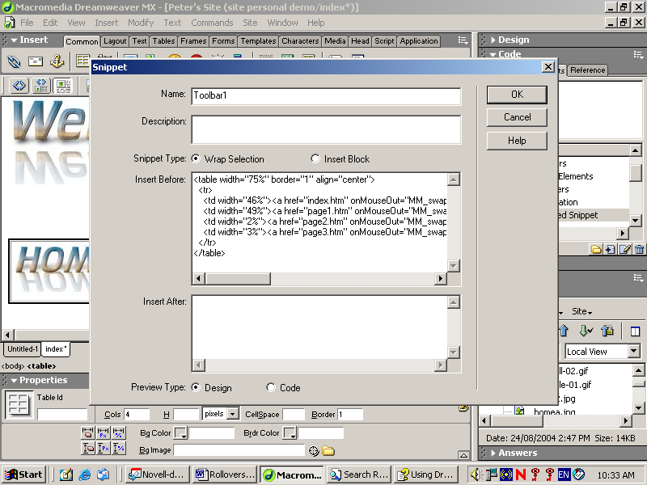
- Save your document (File > Save).
To use the snippet click on it and drag Toolbar1 onto Dreamweaver at the point where you want it to appear. Or Click on INSERT
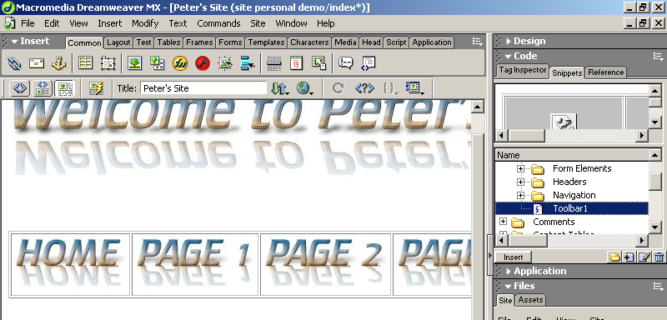

You can also import a button using Insert Flash Button or make your own buttons. NOTE: For most web browsers you will need to remove code <noscript> and </noscript> for each button – bit of a pain but personally I prefer to create my own rollovers.

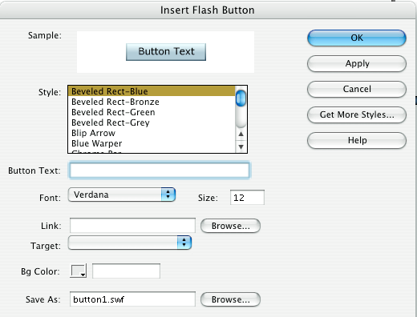

Making buttons in a Photoshop Paintshop pro or any graphics program

Create a button (draw a rectangle) colour it then add text save as image2.jpg
now change the background or text and save this as image2.jpg


HOME
HOME

